Write a program to rotate a square
#include<stdlib.h>
#ifdef __APPLE__
#include<openGL/openGL.h>
#include<GLUT/glut.h>
#else
#include<GL/glut.h>
#endif
float ballX = -0.3f;
float ballY = 0.0f;
float ballZ = -1.0f;
static int flag=1;
void drawBall(void) {

glColor3f(1.0, 1.0, 0.0); //set ball colour
glTranslatef(ballX,ballY,ballZ); //moving it toward the screen a bit on creation
glutSolidSphere (.1,40,40); //create ball.

}

void keyPress(int key, int x, int y)
{
if(key==GLUT_KEY_RIGHT)
ballX += 0.05f;
if(key==GLUT_KEY_LEFT)
ballX -= 0.05f;
if(key==GLUT_KEY_UP)
ballY +=0.05f;
if(key==GLUT_KEY_DOWN)
ballY -=0.05f;

glutPostRedisplay();
}

void initRendering()
{
glEnable(GL_DEPTH_TEST);
}

//Called when the window is resized
void handleResize(int w, int h) {
//Tell OpenGL how to convert from coordinates to pixel values
glViewport(0, 0, w, h);

glMatrixMode(GL_PROJECTION); //Switch to setting the camera perspective

//Set the camera perspective
glLoadIdentity(); //Reset the camera
gluPerspective(45.0, //The camera angle
(double)w / (double)h, //The width-to-height ratio
1.0, //The near z clipping coordinate
200.0); //The far z clipping coordinate
}

void drawScene()
{
glClear(GL_COLOR_BUFFER_BIT|GL_DEPTH_BUFFER_BIT);
glMatrixMode(GL_MODELVIEW);
glLoadIdentity();
drawBall();
glutSwapBuffers();
}

void update(int value) {
if(flag)
{
ballX += 0.001f;
if(ballX>0.3)
{
flag=0;

}
}
if (!flag)
{
ballX -= 0.001f;
if(ballX<-0.3)
{
flag=1;

}
}

glutPostRedisplay(); //Tell GLUT that the display has changed

//Tell GLUT to call update again in 25 milliseconds
glutTimerFunc(25, update, 0);
}

int main(int argc,char** argv)
{
glutInit(&argc,argv);
glutInitDisplayMode(GLUT_DOUBLE|GLUT_RGB|GLUT_DEPTH);
glutInitWindowSize(400,400);
glutCreateWindow("Graphics lab");
initRendering();
glutDisplayFunc(drawScene);
glutSpecialFunc(keyPress);
glutReshapeFunc(handleResize);
glutTimerFunc(25, update, 0);
glutMainLoop();
return(0);
}
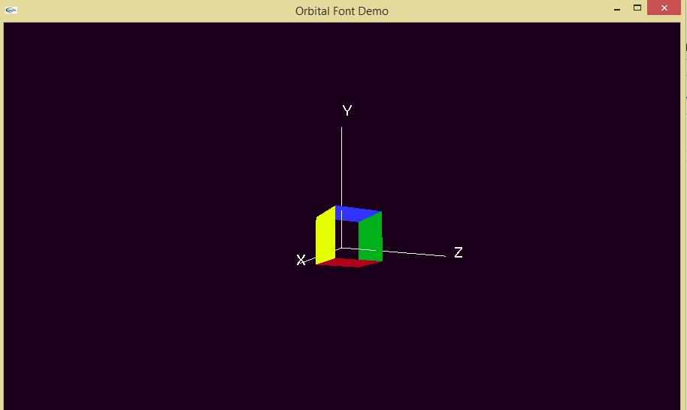
Write a program to collide 2 balls

#include<windows.h>
#ifdef __APPLE__
#include<GLUT/glut.h>
#include<openGL/openGL.h>

#else
#include<GL/glut.h>
#endif

float x1=-2.0,x2=2.0;
static int flag=1;
void initRendering()
{
glEnable(GL_DEPTH_TEST);
}

void reshape(int w,int h)
{
glViewport(0,0,w,h);
glMatrixMode(GL_PROJECTION);
glLoadIdentity();
gluPerspective(45,w/h,1,200);
}

void keyPressed(int key,int x,int y)
{
if(key==GLUT_KEY_LEFT)
{}
}

void drawBall1()
{
glColor3f(1.0,0.0,0.0);
glPushMatrix();
glTranslatef(x1,0.0,-5.0);
glutSolidSphere(0.4,20,20);
glPopMatrix();
}

void drawBall2()
{
glColor3f(0.0,0.0,1.0);
glPushMatrix();
glTranslatef(x2,0.0,-5.0);
glutSolidSphere(0.4,20,20);
glPopMatrix();
}

void update()
{
if(flag)
{
x1+=0.005;
x2-=0.005;
if(x1>-0.35)
flag=0;
}
if(!flag)
{
x1-=0.005;
x2+=0.005;
if(x1<-2.0)
flag=1;
}
}
void display()
{
glClear(GL_COLOR_BUFFER_BIT|GL_DEPTH_BUFFER_BIT);
glMatrixMode(GL_MODELVIEW);
glLoadIdentity();
//glShadeModel(GL_SMOOTH);
drawBall1();
drawBall2();
update();
glutSwapBuffers();
}

int main(int argc,char **argv)
{
glutInit(&argc,argv);
glutInitDisplayMode(GLUT_DOUBLE|GLUT_RGB|GLUT_DEPTH);
glutInitWindowSize(400,400);
glutCreateWindow("Collision Window");
initRendering();
glutDisplayFunc(display);
glutIdleFunc(display);
glutReshapeFunc(reshape);
glutSpecialFunc(keyPressed);
glutMainLoop();
return(0);
}

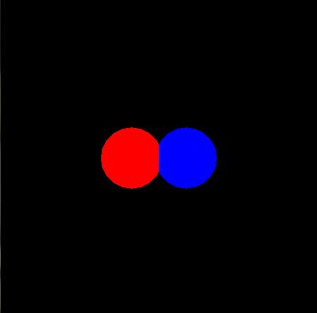

Write a program to rotate a ball on circumference of another circle
#include <GLUT/glut.h>
#include <OpenGL/gl.h>
#include <OpenGL/glu.h>
#include <math.h>
#include <stdio.h>
#include <string.h>
#define WIDTH 640
#define HEIGHT 480
#ifdef __APPLE__
#include<GLUT/glut.h>
#include<openGL/openGL.h>
#include<math.h>
#include<stdio.h>

#else
#include<GL/glut.h>
#endif

float x1=1.0,x2=1.0,an=0,bn=0,ca=0.0009,da=0.0009;
float x3=-99.0,x4=-99.0;
void initRendering()
{
glDisable(GL_DEPTH_TEST);
}

void reshape(int w,int h)
{
glViewport(0,0,w,h);
glMatrixMode(GL_PROJECTION);
glLoadIdentity();
gluPerspective(45,w/h,1,20);
}

void keyPressed(int key,int x,int y)
{
if(key==GLUT_KEY_LEFT)
{}
}

void Ball()
{
glColor3f(0.0,0.0,1.0);
glPushMatrix();
glTranslatef(0,0,-5.0);
glutSolidSphere(0.9,45,9);
glPopMatrix();
glColor3f(0.0,1.0,0.0);
glPushMatrix();
glTranslatef(-x2,-x1,-6.5);
glutSolidSphere(0.2,9,9);
glPopMatrix();
}

void update()
{
an += da;
x1=sin(an);
x2=cos(an);

}
void display()
{
glClear(GL_COLOR_BUFFER_BIT|GL_DEPTH_BUFFER_BIT);
glMatrixMode(GL_MODELVIEW);
glLoadIdentity();
printf("HELLO WORLD\n");
Ball();
update();
glutSwapBuffers();
}

int main(int argc,char **argv)
{
glutInit(&argc,argv);
glutInitDisplayMode(GLUT_DOUBLE|GLUT_RGB|GLUT_DEPTH);
glutInitWindowSize(400,400);
glutCreateWindow("Collision Window");
initRendering();
glutDisplayFunc(display);
glutIdleFunc(display);
glutReshapeFunc(reshape);
glutSpecialFunc(keyPressed);
glutMainLoop();
return(0);
}

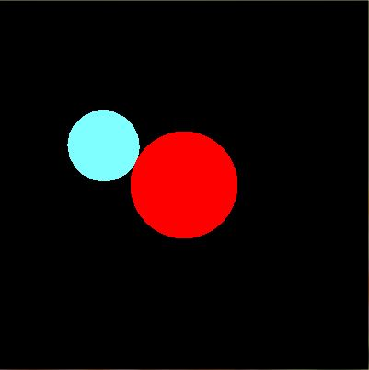

Write a program to where object will follow mouse path

#include<windows.h>
#include<string.h>
#include<stdio.h>

#ifdef __APPLE__
#include<GLUT/glut.h>
#include<openGL/openGL.h>
#else
#include<GL/glut.h>
#endif

double arr[5000][4];
int z=0;
int flag=0;
float radius=0.03;
int ptr=0;
int faltu_bit=1;
float color[3][3]={{1.0,1.0,1.0},{1.0,1.0,0.0},{0.0,1.0,0.0}};
void init()
{
glClearColor( 0.0, 0.0, 0.0, 1.0);
glMatrixMode( GL_PROJECTION);
gluOrtho2D(0.0,600,0.0,600);
memset(arr,0,5000);
glPointSize(20.0);
}

void resetAll()
{
memset(arr,0,5000);
z=0;
}

///OPENGL MAPPING///
float getOpenGLX(int x)
{
double ox = x/ (double)600*(600);
return ox;
}

float getOpenGLY(int y)
{
double oy = (1 - y/ (double) 600)*600;
return oy;
}

void drawPoints()
{
glBegin( GL_POINTS );
glColor3f( 0.0,1.0,0.0 );
for ( int i = 0; i < z; i++ )
{
glVertex2f( arr[i][0],arr[i][1]);
}
glEnd();
}

void drawBall(float x,float y)
{
glBegin( GL_POINTS);
glColor3f( 1.0,1.0,0.0 );
glVertex2f(x,y);
glEnd();
}

void drawLines()
{
glBegin(GL_LINES);
glColor3f(1.0,0.0,0.0);
for(int i=0;i<z;i++)
{
glVertex2f(arr[i][0],arr[i][1]);
}
glEnd();
}

void addValue(int x,int y)
{
arr[z][0]=getOpenGLX(x);
arr[z++][1]=getOpenGLY(y);
}

void trackBall()
{
drawPoints();
}

void myDisplay()
{
glClear( GL_COLOR_BUFFER_BIT);
if(!flag)
{
drawLines();
if(!faltu_bit)
drawBall(arr[ptr][0],arr[ptr][1]);
}
glutSwapBuffers();
glutPostRedisplay();
glFlush();
}

void myMouseStat(int button,int state,int x, int y)
{
if(button==GLUT_LEFT_BUTTON && state==GLUT_DOWN)
{
if(!flag)
{
if(faltu_bit)
{
faltu_bit=0;
}
resetAll();
flag=1;
}
}
else if(button==GLUT_LEFT_BUTTON && state==GLUT_UP)
{
if(flag)
{
ptr=0;
flag=0;
}
}
}

void myPressedMove(int x,int y)
{
if(flag)
{
addValue(x,y);
}
}

void myTimer(int t)
{
if(ptr!=z)
{
ptr++;
}
else
{
ptr=0;
}
glutTimerFunc(100,myTimer,0);
}

int main( int argc, char ** argv)
{
glutInit( &argc, argv);
glutInitDisplayMode( GLUT_DOUBLE| GLUT_RGB);
glutInitWindowPosition( 100, 100);
glutInitWindowSize(600,600);
glutCreateWindow( "Mouse Path");
init();
glutDisplayFunc(myDisplay);
glutMouseFunc(myMouseStat);
glutMotionFunc(myPressedMove);
glutTimerFunc(100,myTimer,0);
glutMainLoop();
return 0;
}

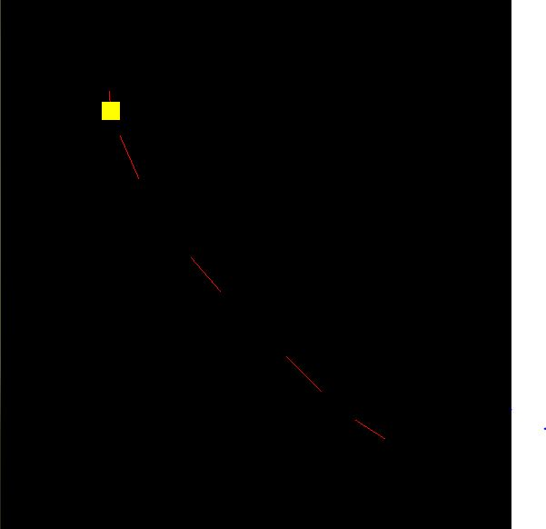

Write a program to inscribe desired number of square in a square
#include<stdlib.h>
#ifdef __APPLE__
#include<openGL/openGL.h>
#include<GLUT/glut.h>
#else
#include <GL/glut.h>
#include <math.h>
#include <stdio.h>
#include <string.h>
#endif
using namespace std;

//using namespace std;
int n;
/*float ballX = -0.3f;
float ballY = 0.0f;
float ballZ = -1.0f;*/
float ballX=-0.3f;
float ballY=-0.3f;
float ballZ=-1.0f;

float ballX2 = 0.3f;
float ballY2 = 0.0f;
float ballZ2 = -1.0f;

float c1,c2,c3;
void drawBall(void) {

glColor3f(1.5, 0.5, 0.3); //set ball colour
glTranslatef(ballX,ballY,ballZ); //moving it toward the screen a bit on creation
glutSolidSphere (0.1, 40, 40); //create ball.
}

void init()
{
//cout<< "Enter the number of figures"<< endl;
//cin>>"%d">>n;
printf("Enter the number of figures ");
//scanf("%d",&n);
scanf_s("%d",&n);
}

void drawBall2(int k) {

glColor3f(1.0, 1.0, 0.0); //set ball colour
glVertex3f(0.05,0.05,0.0);
glVertex3f(0.5,0.05,0.0);
glVertex3f(0.5,0.5,0.0);
glVertex3f(0.05,0.5,0.0);
glEnd();
*/
glBegin(GL_LINE_LOOP);
glVertex3f(-0.25/k,-0.25/k,0.0);
glVertex3f(0.25/k,-0.25/k,0.0);
glVertex3f(0.25/k,0.25/k,0.0);
glVertex3f(-0.25/k,0.25/k,0.0);
glEnd();
glBegin(GL_LINE_LOOP);
glVertex3f(0.0,-0.25/k,0.0);
glVertex3f(0.25/k,0.0,0.0);
glVertex3f(0.0,0.25/k,0.0);
glVertex3f(-0.25/k,0.0,0.0);
glEnd();
}
void drawRectangle() {
glColor3f(0.0,1.0,0.0);
glTranslatef(ballX2,ballY2,ballZ2); //moving it toward the screen a bit on creation

//glTranslatef(0.3,0.0,-1.0);
glBegin(GL_POLYGON);
glVertex3f(0.25,0.25,0.0);
glVertex3f(0.75,0.25,0.0);
glVertex3f(0.75,0.75,0.0);
glVertex3f(0.25,0.75,0.0);
glEnd();

void initRendering()
{
glEnable(GL_DEPTH_TEST);
}

//Called when the window is resized
void handleResize(int w, int h) {
//Tell OpenGL how to convert from coordinates to pixel values
glViewport(0, 0, w, h);

glMatrixMode(GL_PROJECTION); //Switch to setting the camera perspective

//Set the camera perspective
glLoadIdentity(); //Reset the camera
gluPerspective(45.0, //The camera angle
(double)w / (double)h, //The width-to-height ratio
1.0, //The near z clipping coordinate
200.0); //The far z clipping coordinate
}

void drawScene()
{
int x=1;
glClear(GL_COLOR_BUFFER_BIT|GL_DEPTH_BUFFER_BIT);
glMatrixMode(GL_MODELVIEW);
glLoadIdentity();
glTranslatef(0.0,0.0,-1.0);
drawBall2(1.0);
for(int i=1;i<n/2;i++){
drawBall2(2.0*x);
x=x*2;}
glutSwapBuffers();
}

//float _angle = 30.0f;
void update(int value) {
glutPostRedisplay(); //Tell GLUT that the display has changed

//Tell GLUT to call update again in 25 milliseconds
glutTimerFunc(25, update, 0);
}

int main(int argc,char** argv)
{
init();
glutInit(&argc,argv);
glutInitDisplayMode(GLUT_DOUBLE|GLUT_RGB|GLUT_DEPTH);
glutInitWindowSize(800,800);
glutCreateWindow("lab");
initRendering();
glutDisplayFunc(drawScene);
//glutKeyBoardFunc(keyPress);
//glutKeyboardFunc(keyPress);
//glutSpecialFunc(keyPress);
glutReshapeFunc(handleResize);
//autorot();
glutTimerFunc(25, update, 0);
glutMainLoop();
return(0);
}

